# **10 Irresistible Gift Hampers for Her That She’ll Absolutely Love**

Finding the perfect gift for the incredible women in our lives isn’t always easy. Whether it's your partner, mother, sister, best friend, or colleague, you want your gift to reflect appreciation, warmth, and a touch of indulgence. That's where[**gift hampers for her**](https://exclusively-luxe.com/collections/gift-hampers-for-her) come into play. With a curated collection of thoughtful, hand-picked items, hampers have become a sophisticated way to spoil someone you care about.

At Exclusively Luxe, our hampers are more than just gifts—they’re experiences in a box. Let’s explore ten show-stopping options that promise to bring joy and leave a lasting impression.

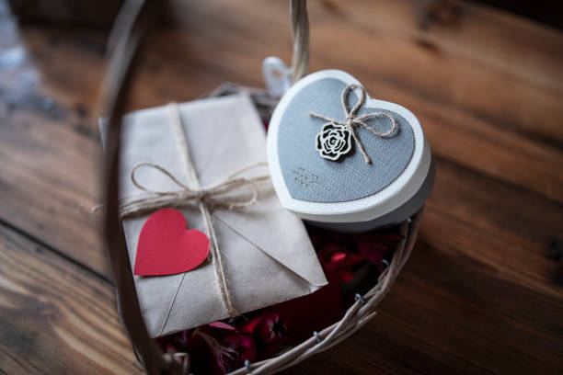

## **Spa Retreat at Home Hamper**

This luxurious gift hamper is a sanctuary in a box. Designed for the woman who deserves a break (and don’t we all?), it includes aromatic bath salts, an essential oil diffuser, natural soy candles, a plush robe, and herbal tea. After a long day, she can sink into serenity without stepping out of her home.

Why it’s loved: Self-care is the new luxury. The calming scents and pampering products elevate everyday rituals into memorable experiences.

**Sweet Indulgence Chocolate Hamper**

For the sweet-toothed goddess, nothing says “I adore you” like a box filled with artisanal chocolates. From velvety truffles to cocoa-dusted almonds, this hamper is a delicious journey through gourmet cocoa creations.

Perfect for birthdays, Valentine’s Day, or just because.

Why it’s loved: Decadent and delightful, it's a mood-lifting treat that never fails to impress.

**The Tea Lover’s Treasure**

Ideal for anyone who appreciates the simple pleasure of a steaming cup of tea, this hamper includes a curated collection of global loose-leaf teas, a ceramic teapot, honey sticks, and handmade tea biscuits.

Why it’s loved: It transforms teatime into a calming ritual, a moment of peace in a busy world.

**Luxury Wine & Cheese Delight**

Looking to impress? This hamper oozes sophistication. Featuring premium wine, aged cheeses, crackers, and a sleek cheese board set, it’s perfect for romantic evenings or celebratory moments.

Why it’s loved: Classy, chic, and ready for an instant soirée.

**Beauty & Glow Skincare Hamper**

Packed with high-end skincare essentials like rejuvenating serums, facial rollers, masks, and moisturizers, this gift is every skincare enthusiast’s dream.

Why it’s loved: It caters to her desire for radiant, glowing skin and includes brands she’s likely been eyeing.

**Mindfulness & Wellness Hamper**

In today’s fast-paced world, mindfulness matters. This hamper includes a gratitude journal, calming incense, meditation guides, herbal teas, and even a miniature Zen garden.

Why it’s loved: Thoughtful and therapeutic, it helps her slow down and reconnect with herself.

**Gourmet Breakfast Hamper**

Start her morning with joy! This delightful basket includes artisanal jams, pancake mix, freshly ground coffee, croissants, and granola—all wrapped in elegance.

Why it’s loved: Breakfast in bed has never felt this good—or looked this pretty.

**Date Night in a Box**

Can’t go out? Bring the romance home. This hamper features everything from sparkling wine to movie-night snacks, scented candles, and a “50 questions for couples” game.

Why it’s loved: It’s playful, personal, and perfect for rekindling connection.

**Eco-Friendly Green Goddess Hamper**

For the eco-conscious woman, this hamper includes biodegradable beauty products, reusable items like bamboo cutlery, organic soaps, and sustainable snacks.

Why it’s loved: Stylishly sustainable, this hamper is both kind to her and the planet.

**Exclusively Luxe Signature Hamper**

Of course, we saved the best for last. Our signature hamper is the epitome of elegance—curated with hand-picked luxuries including fine wine, deluxe chocolates, silk scarves, artisan skincare, and bespoke candles.

Why it’s loved: It represents the core of Exclusively Luxe—a blend of sophistication, quality, and care.

**Why Choose Gift Hampers for Her?**

[**Gift hampers for her**](https://exclusively-luxe.com/collections/gift-hampers-for-her) are more than presents; they are curated experiences that show how much thought and love went into the gift. They're versatile for any occasion—be it birthdays, anniversaries, Mother’s Day, or just a meaningful surprise.

When you choose Exclusively Luxe, you're not just gifting objects—you’re gifting memories, relaxation, and joy.

**Conclusion**

A well-crafted gift hamper is the ultimate way to show love, appreciation, and thoughtfulness. Whether she’s into skincare, wine, mindfulness, or sweet treats, there’s a perfect hamper waiting to make her day. With [**Exclusively Luxe**](https://exclusively-luxe.com/), you can rest assured that every box is designed with elegance and delivered with care.

So, don’t wait for a special occasion—make *any* day special with one of our exquisite gift hampers for her.

**FAQs**

**What makes gift hampers for her special?**

Gift hampers offer a blend of thoughtfulness and indulgence. Each item is carefully selected to suit a theme, making them more meaningful than generic gifts.

**Can I customize a hamper from Exclusively Luxe?**

Yes, Exclusively Luxe allows full customization. You can swap items or build a hamper from scratch to suit her preferences.

**Are gift hampers suitable for corporate gifting?**

Absolutely. We offer elegant, branded hampers that are perfect for clients or team members—thoughtful and professional.

**Do you offer same-day delivery?**

In select cities, yes! Our express delivery service ensures your hamper reaches her doorstep just in time.

**What occasions are best for giving gift hampers?**

Any occasion is a good one! Birthdays, graduations, baby showers, bridal parties, Christmas, or even spontaneous surprises are all great reasons.

**Is it possible to add a personal note?**

Of course! Every Exclusively Luxe hamper includes the option to add a handwritten note or custom message.