DEEPAK --- aaj to college se jaldii aagyaaaa , or aaj to ghar pe koi nahi hei , maa bhi 4 din ke liye bahar gyii hu ... aachaa se maza krugaa ..
vo savita bhi aanee walli hogi khana bnaane ke liye thore deer mei --
tab tak mei kyaaa kru ---- hilaaa lu kyaa waise bhi sala lauda lagaa huaa hei ..
( deepak bedroom mei jaata hei , or kapde khol ke bed mei leet jataa hei)
ajj kal toh salaa koi porn bhi aacha nhi hei haat madarchoddd kissi mei joshh hei naahi aarha hei ..
maan to kr rha hei kiseko pataak ke chooddd de puraaa , lunddd uska muuh , chuut , gaand sab mei ghussa ke peel de puraaaa ......


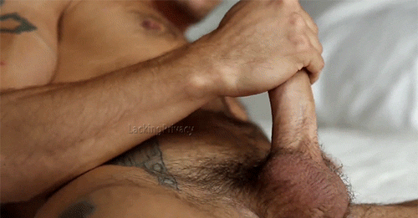

AAHHHHH …KISKAAA CHUUTTT CHAHIYEEEEE —-

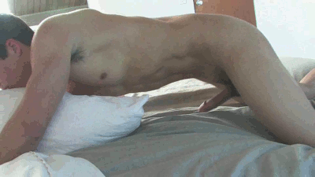

AAHHHH AAAAHHHHHH BEHNCHOODDDDDD —---

SAVITA - “” BHAIYYAAA GATE KHOLIYEEE MEIII HU SAVITAAAAA”

DEEPAK - haaat behnchodd …. Thik se koii helaane bhi nhi deta hei ….

“ RUKKKK AARHHA HU “

DEEPAK - Mei gayaa or gate kholaaa to dekhaa savitaaa khadi hei geeli badaaann

Meine usse puchaaa – ye tere badan geele kese hei

Savita - ooo chote baba barish horhi thi to bheeg gyi thora sa ..

Deepak - aacha jaa kapde change krle

Savita - haa chote baba kya khyege aappp , malkin to nahi hei ….

Deepak - haa dekh le bnaa de kuch bhi

Savita - thik hei chote baba mei kapde change krke aapke liye bnaa deti hu

( Deepak - merii nazaar uske chhucche se haat nhi rhii thiii - bhut baade chuuche hei uskeee — or paniii uskiii chuche ke bich mei hei jha rhaa heii — aagar issko pelne ka mokka mil jataa to mazaa hei aajata , aab to mei isko hei choduungaaa )

Savitaa ek chote kamre mei gyi - jhaa uske kapde theee —
Mei bhi uske piche gyaaaaaa , usne apne saree ka pallu hataaaa uskaa peeth dekh rha tha vo thori side ghummi to uska kamaar bhi dekh rha thaa or left walaaa boobs bhi dekhne lgaaa mei lunddd ekdm khddaa hogyaaaa —--
Aab mera bhut maan horha hei iskoo chodnee kaaaa ufffffff —--

VO DHEERE DHEERE APNE SARE KAPDEEE KHOLII OR NANGII HOGYIII USKEE BADDEE BAADEEEE CHUCCHEEEE DEDKHH UCHAAL KE BHAAR AAGYE …..
UFFFF MERA ITNA MAAN KR RHA HEI AAB ISS RANDI KO CHODNE KAAAA

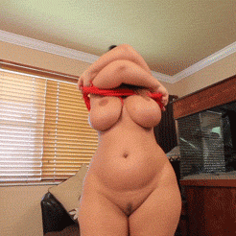

MEII USKI BAHAADAAN KO DEKHHH KE AAPNAA LAUDAAAA HILANEE LAGAAAA —- AAAAHHHHHHHHH …. OR MEINE SOCH LIYAA AAAB MEI ISSE CHODD KE HEI RHUGAA AAJ aaahhhhhhhhaa aaahhhh

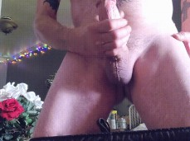

Usko eseee dekh ke mera to paani heii aagyaa salaa lkn mera lundd shant nhi huaa hei …. Mujhee usseee chodnaa hei h…….

VO tgori deer baad room se nikli or kitchen mei chali gayiiii…

Mei dheere se uskee pass gyaaaa or piche se uskaaa kamaar pakraaa
.


SAVITA - CHOTEE BABA YE KYAA KR RHE HEI TUM …..

DEEPAK ( USKI NECK MEI KISS DETEE HUEE KAHAA

MUJHE PTAA HEI RANDI TERI BHI CHUUT EK ASLI MARD KI LUND KA INTZAAR KRTA HEI ..
TERI SARABI PATI TO TUJHEE THIK SE CHOODD BHI NHI PAATAAA HOGAAA –
MERE LUND KI SAWARII KRLEEEE JANAAT DEKHAA DU TUJHEE ..

SAVITAAA - YE KYA BOL RHE HEI AAP SHARM NHI AARHAA HEI

DEEPAK USKI CHUUT CHUTTEE HUE BOLAA -
TERI CHUUT BHI GELLI HOGYI DEKH LE MERE KARREB SE HEI ..
JAB MERA LUND TERA CHUUT MEI JAYEGAA TAB KYA HOGAA —-

CHUDWANAAA HO TO 10 MIN MEI ROON AAJAANNAAA — ACHEEE SE CHUDAAYI KRUGNAA TERIIII —

YEEEH BOLTE DEEPAK ROOM MEI CHALAA GYAAAA —-- OR TURNTT USKI GATE MEI KNOCK AAYAAA -

VO HASTEE HUEE BOLAA AJAA RANDI ROOM KHULAA HEI –

SAVITA USKE PASS GYI —- LKN CHOTE BABA KISEKO PTAA CHALAA TOO –

DEPPAK USSE BOLAA – NHI PATAA CHLEGAAA -

CHALL BLOUSEEE KHOLL OR SARRE HATAAA —- OR MERAA LUNDD CHUUSSS AAAKEEEEEEEEE

