deepak - chal blouse khol randiiii ------- or ghuntoo pee beth or mera lund muuh mei leeeee ----
Savitaaa - ji choteee babaaaa ----
Deepak uske boobssss pe ek chaataa martaa hei or bolta hei - maalik bol randi ......
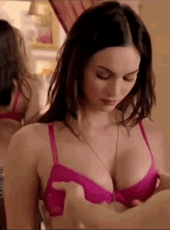
Savita ---- aah ji maalik
deepak chal beth jldi -------- or chusss
savita aapna blouse kholti hei --- or deepak kaaa lund uska pant se bahar nikaal ke chusne lagti hei -----
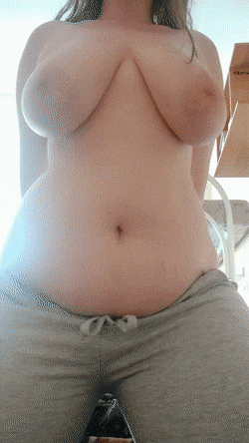

.
vo pheleeee uske lund ko tip pe apne honth lagatiiii heiii or apne haath se usk laure ko dheere dheer upaar nicheee kartiiiii hei --- ye krte hue vo deepak ke taarf dekhti hei —

deeepaaak - aaahhhhhh aahmmmmm tere honth or hath kitnee aahh soft hei –


aahhhh jaldii puraaa lee aandrrrr --- aaahhhh ..

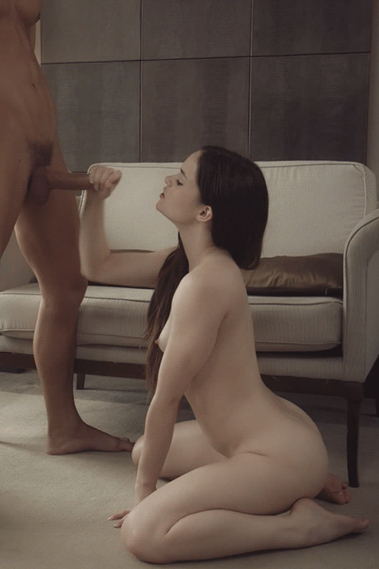
ye sunteee hei --- savitaaa puraa lund apne muuh mei leleti hei orrrr puraa lolipop jesaa chuse lgti hiei
deepak aaahhhhh randiiii aahhhhh aahhhh bass baass esee aahhhh essse hei leeee aahhhh kyaa janaaat lag aaahhh rhaa hie -- ohhhhhhhh --.


deepak aankh banddd krkee puraa puraaa feeel liyee ja rhaa thaa ---
savitaaaa - uskee ballssss ko apne hath se sehlaane lgtii hei ...
deepaakk or bekkaabuu hotee jaaa rha thaaa ----


Deepakk -- aaahhhh savitaaa ranndiiiiiiiiiii ---- aaaaaaaaaaaahhhhhhhhhhhh ... mera ballsss aahhhh mera lunddd ---
meraa aane wallaaa hei bhnchodddddd -- apneee muuh meii leee nikaaalnaaa mt randiiii aaahhhhhhhhhhhh aahhhhhhhh ---- raaandiiiii aagyaaa meraa panni aahh tere liyeeee aahhhhhhhh ...
.
vo puraaa raass uskee muuh mei giiraa detaaaa heiiiiii - –...

